**Operating Systems Lab-7**

**Process Creation and Execution**



Submitted By: **Awais Saddiqui**

Registration# **21pwcse1993**

Section: **“A”**

Submitted to:

**Mam Madiha Sher**

**Department of Computer Systems Engineering**

**University of Engineering and Technology, Peshawar.**

**CSE 302L:** **Operating Systems Lab**

**LAB ASSESSMENT RUBRICS**

|  |  |  |  |  |
| --- | --- | --- | --- | --- |
| **Marking Criteria** | **Exceeds expectation**  **(2.5)** | **Meets expectation**  **(1.5)** | **Does not meet expectation**  **(0)** | **Score** |
| 1. **Correctness** | Program compiles (no errors and no warnings).  Program always works correctly and meets the specification(s).  Completed between 81-100% of the requirements. | Program compiles (no errors and some warnings).  Some details of the program specification are violated, program functions incorrectly for some inputs.  Completed between 41-80% of the requirements. | Program fails to or compile with lots of warnings.  Program only functions correctly in very limited cases or not at all.  Completed less than 40% of the requirements. |  |
| 1. **Delivery** | Delivered on time, and in correct format (disk, email, hard copy etc.) | Not delivered on time, or slightly incorrect format. | Not delivered on time or not in correct format. |  |
| 1. **Coding Standards** | Proper indentation, whitespace, line length, wrapping, comments and references. | Missing some of whitespace, line length, wrapping, comments or references. | Poor use of whitespace, line length, wrapping, comments and references. |  |
| 1. **Presentation of document** | Includes name, date, and assignment title. Task titles, objectives, output screenshots included and good formatting and excellently organized. | Includes name, date, and assignment title.  Task titles, objectives, output screenshots included and good formatting. | No name, date, or assignment title included.  No task titles, no objectives, no output screenshots, poor formatting. |  |

**Instructor:**

Name: __Engr. Madiha Sher___ Signature: ______________________

**Task #1:**

**Code:**

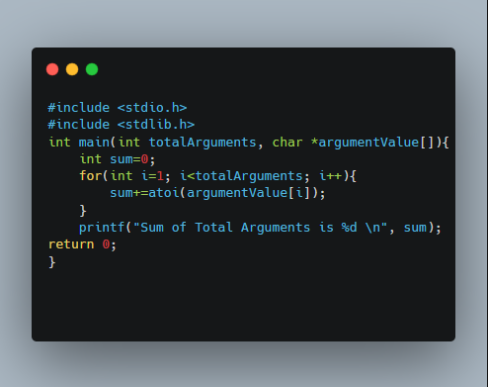

**Output:**

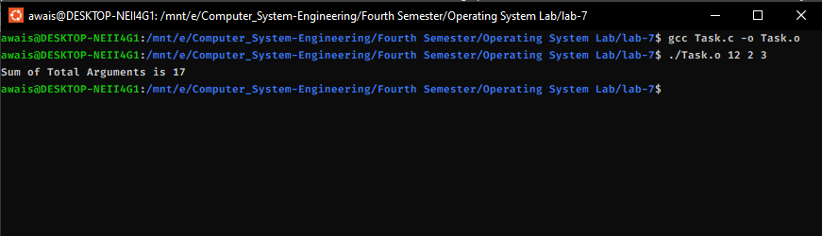

**Task #2:**

**Code:**

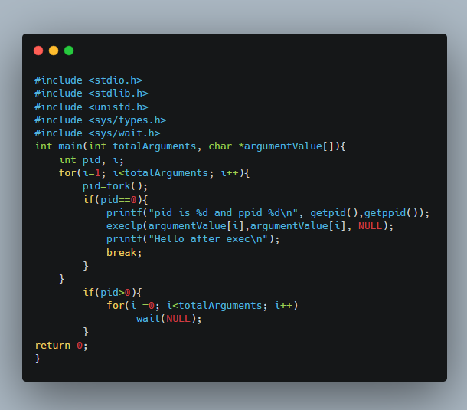

**Output:**

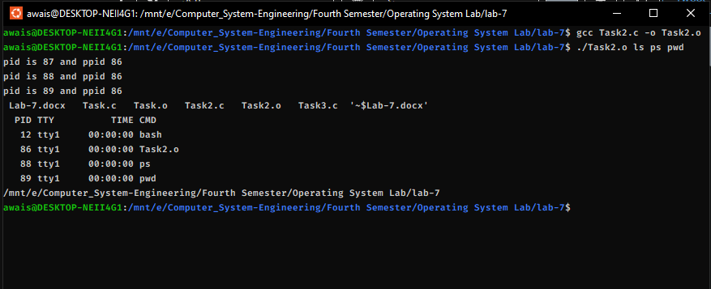

**Task #3:**

**Code:**

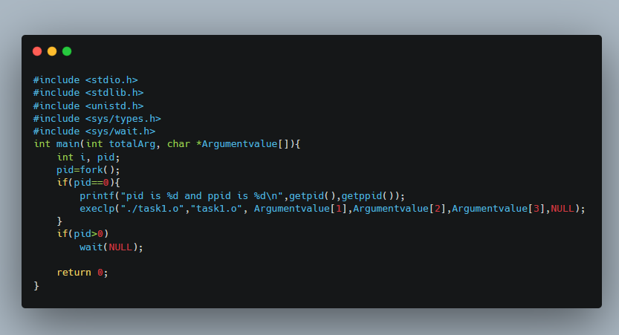

**Output:**

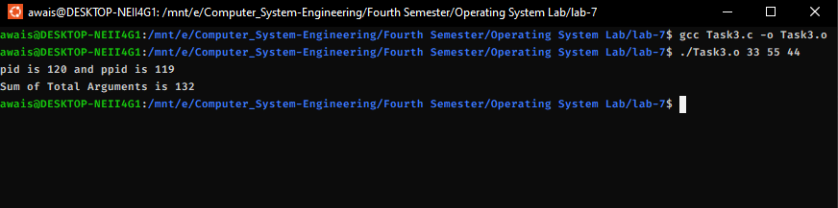

***Source: https://carbon.now.sh/***